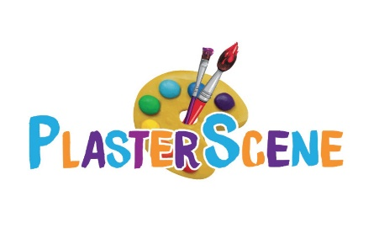

KIDS ART CLUB

REGISTRATION FORM

*Please note that all fields are required for successful enrolment.*

Child's Information:

Full Name: __________________________________________________

Age: _______ Date of Birth: __________

Parent/Guardian Information:

Full Name: ______________________________________________

Relationship to Child: ____________________________________

Email: ___________________________________________________

Phone Number: ___________________________________________

Emergency Contacts:

Name: ____________________ Relation: _____________ Phone: __________

Name: ____________________ Relation: _____________ Phone: __________

Activity of Interest (Choose one or more)

* Kids Art Class □
* Embroidery □
* Clay Building □
* Beadwork □
* Papier Mache □
* Slime □
* Mixed Media Craft □

Terms and Conditions:

* Please read and agree to the terms and conditions outlined in the registration form.
* By completing and submitting this form, you agree to abide by the Kids Art Club policies and guidelines.